USING THE DSP 100 WITH OTHER TRANSCEIVERS.
Antenna connection:
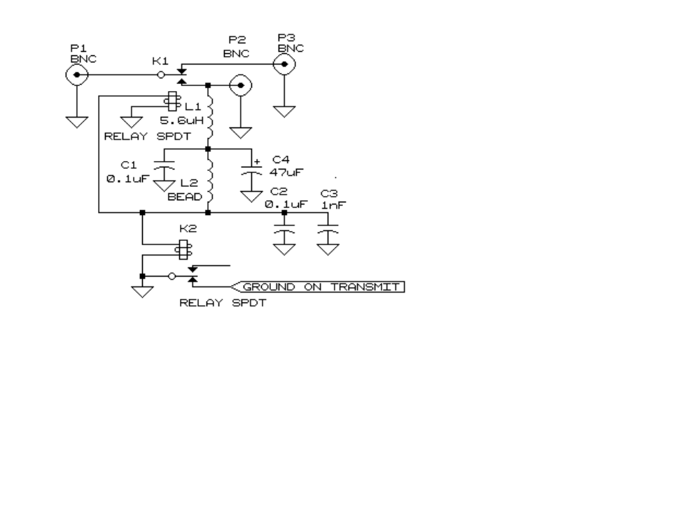
The antenna for the DSP 100 can either be derived from a separate antenna or picked off from the antenna connection to the other transceiver. Two possible ways of arranging the pick off are, using a relay to switch the antenna from the other transceiver to the DSP 100, or high impedance coupling the DSP 100 to the another transceiver antenna. The circuit shown is a relay protected pick off system.

PTT connections:
Using the other transceiver microphone and PTT.
Connect the ‘PTT close to ground on transmit’ of the other transceiver to the DSP 100 PTT on the DSP sound card (pin 2 of the game port) see External PTT Control. When the RX ANT PWR is on in RADWARE the DSP 100 will have the antenna, otherwise the other transceiver will have it.

Using the DSP 100 microphone and PTT.
This is not a simple setup. A lot of care must be taken to ensure that the other transceiver PTT is not held down when not required. If this setup is left connected when the computer is not running RADWARE with the transceiver on it will be in transmit. The only real advantage of this setup is the digital compression used by RADWARE on transmit. With this in mind one must also consider the possible additional stress put on the other transceiver’s power amplifier sections.
Connect the ‘GROUND ON TRANSMIT, shown on the drawing, to the PTT control of the other transceiver. Connect one side of the stereo line output from the sound card to the other transceiver microphone input. Note: although both stereo lines are required when using the DSP 100 as an exciter, the quadrature output is not required in this case. On sound cards without a speaker output jack, a stereo splitter will be required to feed both the loudspeaker and the other transceiver microphone input. It will also be necessary to provide a way of turning off the loud speaker on transmit with these cards. Set the RX ANT PWR on in RADWARE. All RADWARE PTT controls should now operate the other transceiver.

high impedance coupling the DSP 100 to the another transceiver antenna.
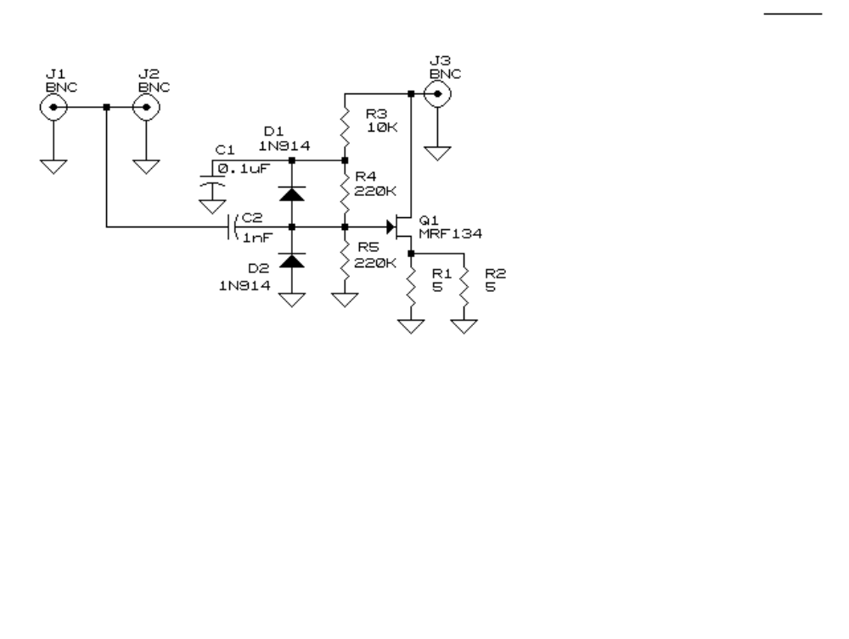
The schematic shows a circuit that allows signals to be picked off a standard transceiver antenna for use with the DSP 100. This unit is available from CCI,
part No ANTAP1

Changing the 12 Volt Fuse.
The DSP 100 has a fuse in the 12 volt supply line. Should an antenna that represents a low DC resistance be connected to the antenna ports with the biases turned on this fuse will blow. If this fuse is blown the DSP 100 will be completely disabled. To change the fuse remove the DSP 100 card from the computer and remove the fuse from its holder with a small pair of tweezers. A spare fuse is provided with the DSP 100, place this new fuse in the holder using the tweezers.


